Student Name : Bryan Lu We Zhern

Group : A52

Date : 30/3/2023

LAB 4: ANALYZING NETWORK DATA LOG

You are provided with the data file, in .csv format, in the working directory. Write the program to extract the following informations.

Exercise 4A: TOp TALKERS and LISTENERS

One of the most commonly used function in analyzing data log is finding out the IP address of the hosts that send out large amount of packet and hosts that receive large number of packets, usually know as TOP TALKERS and LISTENERS. Based on the IP address we can obtained the organization who owns the IP address.

List the TOP 5 TALKERS

Rank | IP address | # of packets | Organisation
1 | 193.62.192.8 | 3041 | RIPE Network Coordination Centre (RIPE)
2 | 155.69.160.32 | 2975 | Asia Pacific Network Information Centre (APNIC)
3 | 130.14.250.11 | 2604 | National Library of Medicine (NLM)
4 | 14.139.196.58 | 2452 | Asia Pacific Network Information Centre (APNIC)
5 | 140.112.8.139 | 2056 | Asia Pacific Network Information Centre (APNIC)

TOP 5 LISTENERS

Rank | IP address | # of packets | Organisation
1 | 103.37.198.100 | 3841 | Asia Pacific Network Information Centre (APNIC)
2 | 137.132.228.15 | 3715 | Asia Pacific Network Information Centre (APNIC)
3 | 202.21.159.244 | 2446 | Asia Pacific Network Information Centre (APNIC)
4 | 192.101.107.153 | 2368 | Battelle Memorial Institute, Pacific Northwest Division (PNNL-Z)
5 | 103.21.126.2 | 2056 | Asia Pacific Network Information Centre (APNIC)

Exercise 4B: TRANSPORT PROTOCOL

Using the IP protocol type attribute, determine the percentage of TCP and UDP protocol

 | Header value | Transport layer protocol | # of packets | Percentage
1 | 6 | TCP | 56064 | 82.37%
2 | 17 | UDP | 9462 | 13.90%
3 | 50 | ESP | 1698 | 2.49%
4 | 47 | GREs | 657 | 0.97%

Exercise 4C: ApplicationS PROTOCOL

Using the Destination IP port number determine the most frequently used application protocol.
(For finding the service given the port number https://www.adminsub.net/tcp-udp-port-finder/ )

Rank | Destination IP port number | # of packets | Service
1 | 443 | 13423 | HTTPS
2 | 80 | 2647 | HTTP
3 | 52866 | 2068 | Dynamic / Private Ports
4 | 45512 | 1356 | Unassigned Ports
5 | 56152 | 1341 | Dynamic / Private Ports

Exercise 4D: Traffic

The traffic intensity is an important parameter that a network engineer needs to monitor closely to determine if there is congestion. You would use the IP packet size to calculate the estimated total traffic over the monitored period of 15 seconds. (Assume the sampling rate is 1 in 2048)

Total Traffic( MB) | 61.7769

Exercise 4E: ADDITIONAL ANALYSIS

Please append ONE page to provide additional analysis of the data and the insight it provides.
Examples include:
Top 5 communication pairs;
Visualization of communications between different IP hosts;
etc.

Please limit your results within one page (and any additional results that fall beyond one page limit will not be assessed).

Top 5 Communication Pair

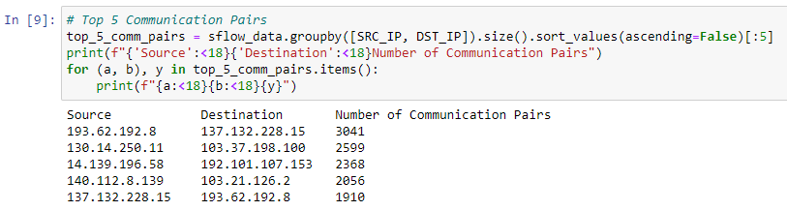

Visualisation

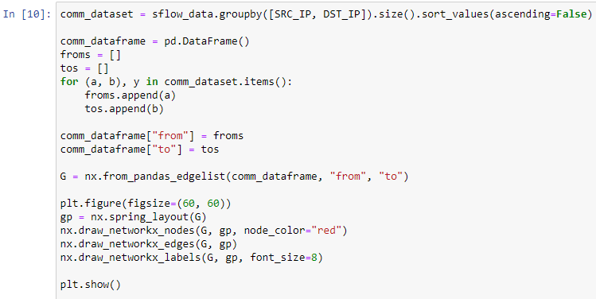
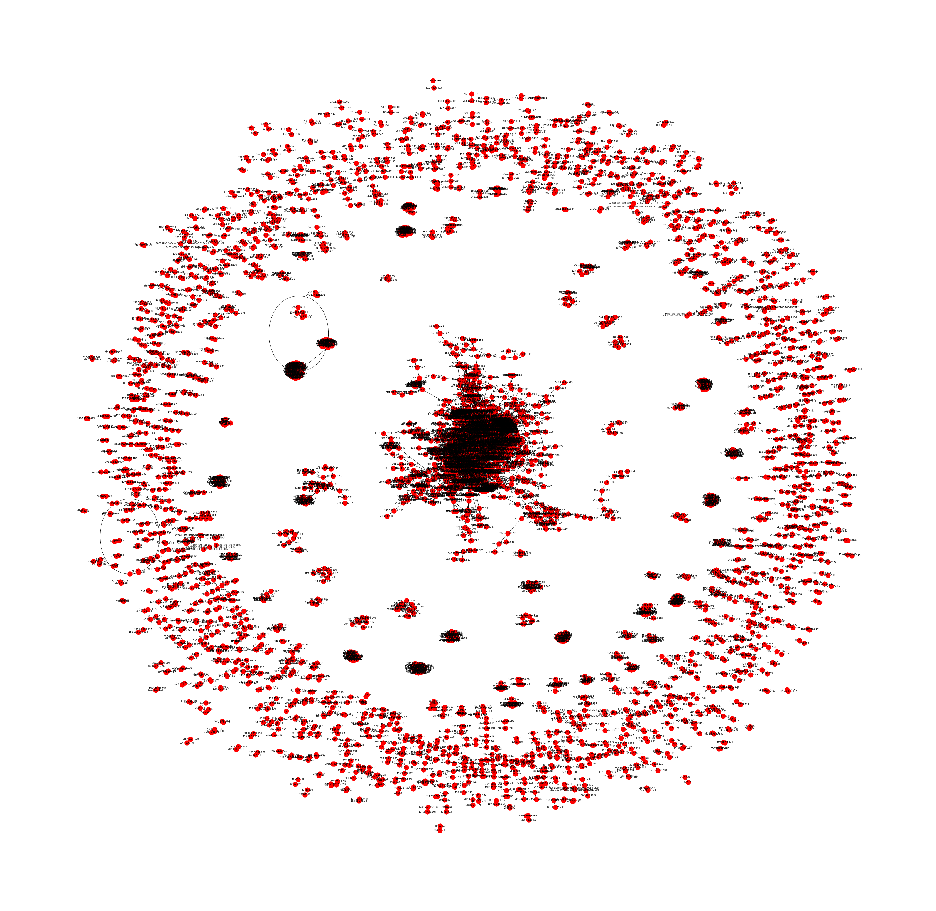

Exercise 4F: SOFTWARE CODE

Please also submit your code to the NTULearn lab site.

